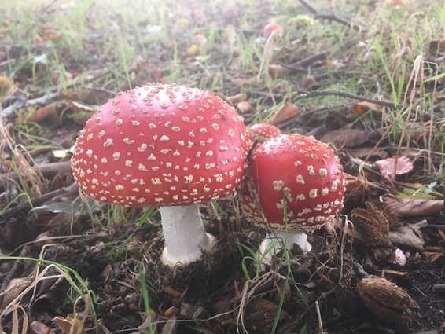
Autumn is a great time to look for the many and varied fascinating species of fungi that thrive in the parkland. Our policy of leaving dead wood in-situ has certainly proved beneficial, not only to fungi but all the other invertebrates that live on decaying wood. This in turn provides a food source and home for birds and other animals. Fungi come in many shapes and sizes but perhaps the most typical is pictured here, a fly agaric. This is the toadstool most associated with children’s fairy tales. Look closely and a whole new world emerges and the variety is breath-taking. Ranging from grassland waxcaps to tree bracket fungi, even tiny specks on a leaf, fungi is everywhere at this time of year doing the important job of breaking down waste material. Why not join us on a guided walk on 13 October when Fungal Punk Dave will show us an insight into this amazing, mysterious world. Details on how to book can be found on our website. Please remember it’s against National Trust byelaws to remove anything from the parkland, so enjoy finding and looking at the fascinating mushrooms but don’t pick them!
The UK Butterfly Monitoring Scheme has been running for many years providing data showing indicators of change and valuable knowledge of butterfly populations in the UK. The scheme is organised and funded by the British Trust for Ornithology and Butterfly Conservation among others. Our Ranger team are involved in this scheme and so far have identified seventeen different species. A transect in the Parkland is walked weekly over summer and into autumn and all butterflies are noted. Taking in various habitat types allows us to show the most important areas for differing species.
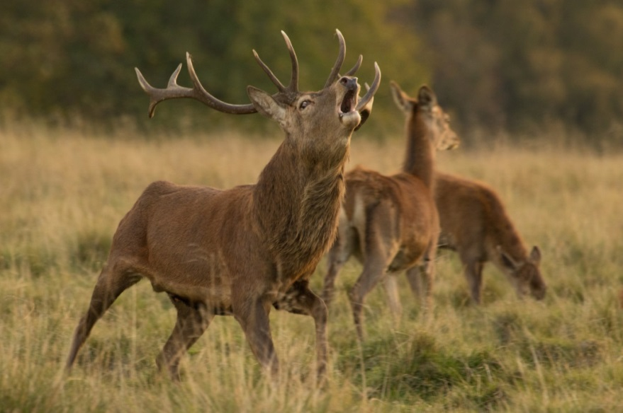
Over the autumn months the deer will be taking part in the annual deer rut and this is a fascinating time to observe them. The stags and bucks have now ‘cleaned up’ their antlers (they have frayed off the velvet that has covered them over the summer months while they have been growing). The rut is triggered by the shortening daylight hours, and the males now prepare by making themselves appear and smell more intimidating. They do this in a number of ways, firstly by raking the ground with their antlers and adorning them with grass. This raking of antlers and the scraping of hooves creates a shallow pool called a wallow in which the animal will urinate and then roll around in, coating himself with the pungent mud. They will now also become more vocal and the deep guttural bellowing call of the red deer can carry for long distances. While the repeated snorting rasp of the fallow deer is often accompanied by parallel walking where two similarly matched bucks can walk alongside each other for long distances weighing each other up before deciding whether to fight. Fighting is a last resort and only tends to happen when two evenly matched males face each other. The deer lock antlers together and the battle ensues which is basically a pushing game to determine the stronger animal. Some injuries and even fatalities do occur but are thankfully uncommon at Tatton Park.
The successful male will mate with the most females, these are usually the stronger animals meaning the best genes will be passed down to the herd. When the bigger stags are exhausted, the younger males may get chance to mate. Two different strategies are used by the two species we have at Tatton. The red deer battle to keep a large group of females together known as a harem which will move around to a certain extent. The fallow bucks hold a territory into which he attracts the females by calling. The “stand”, as it is known, is usually on a raised area and tend to be traditional sites. The autumn crop of acorns and chestnuts are vital to the stags and bucks to replenish their fat reserves before winter sets in as they feed very little and lose condition during the rut. Three guided deer walks are being run during October – they provide a unique opportunity to view and photograph the deer in the parkland, while learning about our herds from the Rangers. Details on how to book can be found on our website..
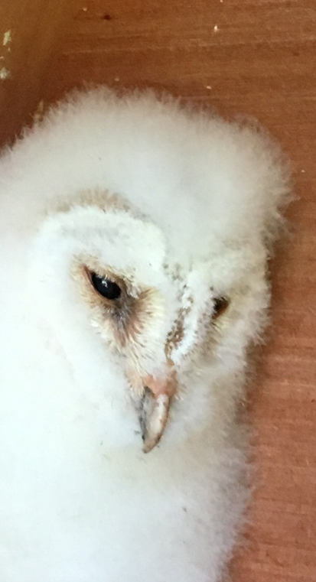
Autumn is also a fascinating time to look at our birdlife as it is the time of year for migration. Our summer visitors leave us for sunnier climes and winter birds join us for our relatively mild winter. As birds move, they can turn up anywhere and this is the time to find something unusual. Wildfowl numbers and variety of species increase and stonechats and meadow pipits join us from higher ground. Winter thrushes arrive in the form of redwing and fieldfare and our resident species are joined by birds of the same species from the continent boosting their numbers. Hobbies have been present over the summer with several sightings in early September as they feed up before migrating to Africa. Common sandpiper, wheatear and barn owls have been seen over summer too. We were delighted to discover the latter nesting in a box erected for them when three chicks were found, one of which is pictured on the left. We have several nest boxes in the Parkland which are checked each year by one of our Rangers who holds a special licence to do so. Family parties of green woodpecker were also spotted meaning they have had a successful breeding season, Tatton Park is one of the most important sites in the county for this species.
For further details on any of our activities, please contact our education team on 01625 374428 or visit our website at www.tattonpark.org.uk. Please note that events need to be pre-booked.

Complied by Tatton’s Ranger Team

